From: | communication@csninc.ca
Date: | Tue, Jan 12, 2016 at 7:19 PM
Subject: | Aviva Canada - Winter Summer Tire Package Verification Program
Message:
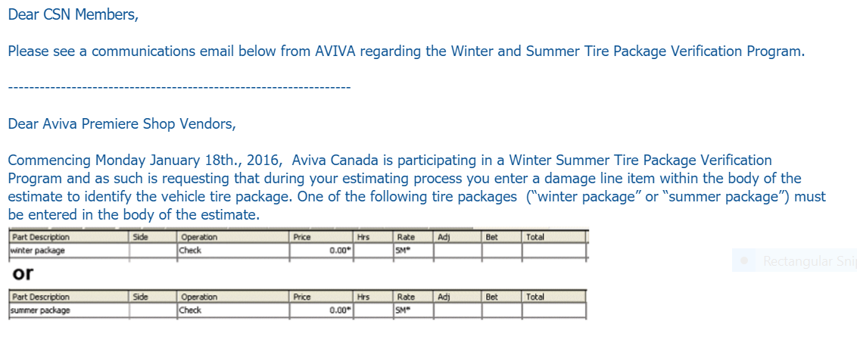
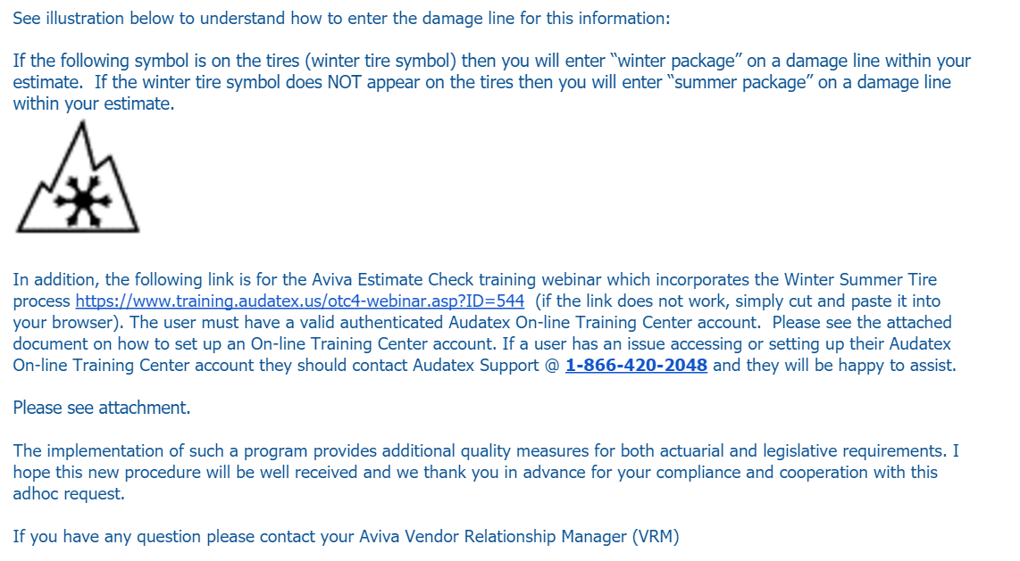

Attachment included? |  | YES

Attachment:

