From: | communication@csninc.ca
Date: | Tue, Feb 2, 2016 at 2:47 PM
Subject: | TD Insurance Enabling Mandatory Field: Drivable/ Non- Drivable
Message:
Good Afternoon TD DRP Partners,

TD Insurance has asked CSN Corporate to forward an email to the DRP shops asking that the “Drivable/ Non-Drivable” field in Mitchell Ultramate is enabled as mandatory.

Attached is a document outlining how to set up a mandatory field in Ultramate.

If you have any questions regarding the set up please contact Douglas White at 647-292-3904 or by email at douglasw@csninc.ca

Attachment included? |  | YES

Attachment: |  | Enabling Mandatory Fields in Ultramate Drivable

Enabling Mandatory Fields in Ultramate
- Login to Mitchell Estimating (Ultramate) with Administrative rights
- Click System Info
  - 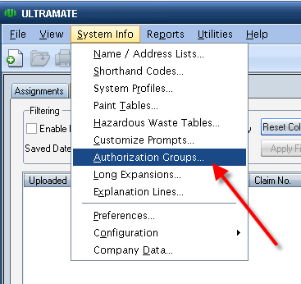
- Select the Shop profile (TD Insurance. Security National, Monnex )
- Click Design Screen
  - 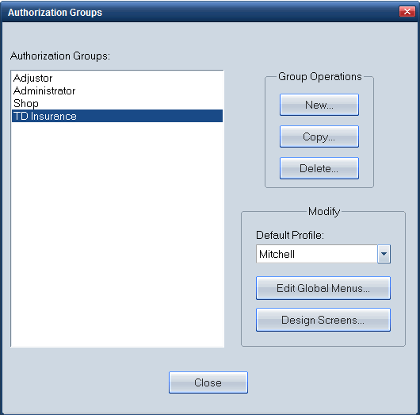
- Editing Tool Bar:
  - 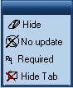
  - These actions may require you to use the following tools bars:
    - Hide Tab
    - Required
- Select - Editing Vehicle tab, and then Vehicle data tab.
  - 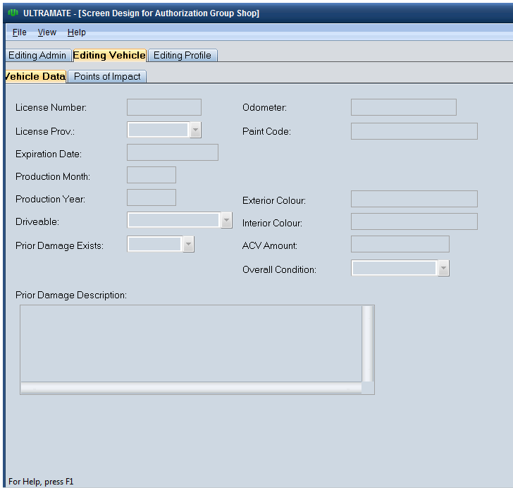

- To make “Drivable” required, click on the “required” toolbar and select the Drivable field.
  - 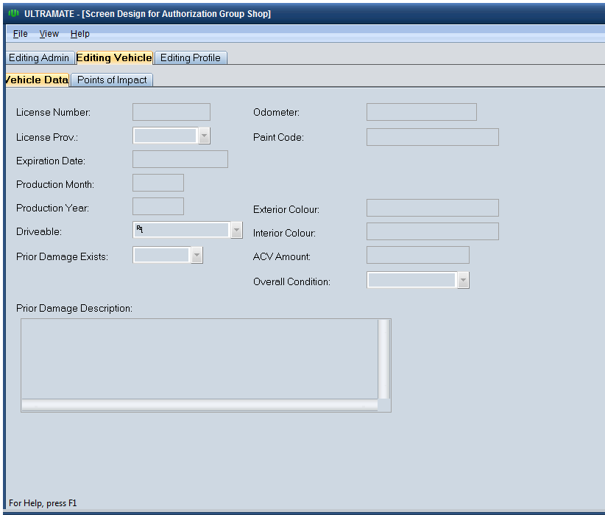

  - Click File
  - Click Save

